SRS Document

MEDIX – Hospital staff scheduling, Hub, and registration
Fatimah, Fazlur, Samuel, and Yusuf

Deliverable #1 (1 Marks) SAMUEL
Based on the list of requirements you gathered in Part A of the project, develop a set of goal use cases per use case identify the actors (Operational stakeholders) involved and the requirements they relate to. Name each use case to reflect the functionality it serves using the name convention “Verb-Noun” group the uses cases under two or three sub-systems / modules. You can base your grouping based on the similar functional areas or based on types of operational stakeholders, who are your end users. Add the use case table to section # 3 of your SRS document.
Check out the safe home case study there is a good example of how use cases can be grouped.
Note: If you have abstract uses cases for example “Log into system” add it at the end of the table and do not enter the actors. Your actors should be operational stakeholders. Per project at least two different actors (operational stakeholders) are required, do not use the term end user, rather have a name for each role.
Use cases
Use Case name | List of related Requirements ID | Actor (s) | Brief Description
Create Scheduling  Create/View Schedule | FR  001 | Hospital Administrator, Hospital Staffs. | - Actor logs into the system.  - Navigates to the scheduling section.  - Chooses to create a new schedule.  - Provides details like date, shift timings, and assigns staff members.  - Saves the new schedule, which is now visible to the staff.  Hospital Staffs.  - Actor logs into the system.  - Navigate to their profile or scheduling section.  - Access and view their assigned schedules.
Staff Registration  Edit Schedule | FR  001 | Hospital Administrator | - Actor logs into the system.  - Navigates to the scheduling section.  - Choose the existing schedule to edit.  - Modifies details like date, shift timings, or assigned staff.  - Saves the edited schedule.
Delete-Schedule | FR001 | Hospital Administrator | - Actor logs into the system.  - Navigates to the scheduling section.  - Choose the schedule to delete.  - Confirms the deletion action.
Register-Staff | FR 002 | Hospital Administrator | - Actor logs into the system.  - Navigates to the staff management section.  - Chooses to register a new staff member.  - Provides required details like name, ID number, and facial identification photo.  - Saves the new staff member's information.
View-Staff-Information | FR 003 FR 004 | Hospital Administrator | - Actor logs into the system.  - Navigates to the staff management section.  - View a list of registered staff with accurate names.  - Views a list of registered staff with accurate ID numbers.  - Views a list of registered staff with accurate facial identification photos.
User Log-In and log-out | FR 002 | Hospital Administrator/ Staff | - Actors navigates to the login section.  - Choose the option to log in with password or facial I.D  - Actors enter their credentials (username and password) on the login screen.  - The system verifies the credentials.  - Upon successful verification, users are granted access to their respective functionalities, daily shift, and task.  - To log out actor navigate to the logout option.  - The system logs them out, terminating their access to the application.
Medical Staff Role | FR 006, FR 007. | Hospital Administrators and Staff. | - Actors log into the system.  - Navigates to the staff management section.  - Access the staff management section.  - Verify and assign "Medical Staff" roles to doctors, nurses, and allied health professionals.
Hospital Support Staff Role | FR  008 | Hospital Administrators and Staff. | - Actor logs into the system.  - Navigate to the staff management section.  - Verify and assign "Hospital Support" roles to relevant staff members.
Scanner API | FR  009 | Hospital Administrators | - Actor logs into the system.  - Access the configuration section for ID cards and scanners.  - Activate the API to ensure functionality.
Push/Banner notifications | FR  010 | Staff | - Actor logs into the system.  - Register and connect their email and mobile number to application notification update.  - Receive push/banner notifications for relevant updates through email or text message.
Staff Communication | FR  011 | Hospital Administration and Staff | - Actors log into the system.  - Access the communication section.  - Send and receive text-based messages with other administrative members and staff.
Staff Requests | FR  012 | Hospital Administrators and *Healthcare Staff. | - Actor logs into the system.  - Navigate to the scheduling or requests section.  - Update available open shift.  - Staff Submit requests for shift changes or availability.  - Actors approve and assign available open shift.
Schedule Views | FR  013 | *Staff | - Actor logs into the system.  - Access the scheduling section.  - View and keep track of their assigned schedules.
Task View | FR  014 | Staff | - Actor logs into the system.  - Navigate to the task view section.  - Access multiple layouts displaying their pending tasks.
GPS based Clock-in technology | FR  015 | Hospital Administrator and staff | - Actor logs into the application.  - Navigate to the time management or attendance section.  - Choose the GPS-based clock-in option.  - Allow employees to clock in remotely ONLY when detected at the facility with GPS.
Paystub/spreadsheet distribution | FR  016 | Finance Department and staff | - Actor logs into the system.  - Access the paystub distribution section.  - Send out password protected paystub to staff through email  - Provide virtual access or download options for end-users.  - Provide access codes to staff.  - Staff receive their paystub through email.
Attendance Report | FR  017 | Hospital Administrator | - Actor logs into the system.  - Access the attendance reporting section.  - Generate and analyze attendance reports for staff members.
Time-Off Management | FR  018 | HR and Staff | - Actor logs into the application.  - Actors navigate to the time-off management section.  - Staff members submit time-off requests through the system.  - Include details like the reason and duration of the time-off.  - Actor reviews and manages time-off requests.  - Accept, decline, or inquire about the request.
Training and Certification Tracking | FR  019 | Human Resources and Staff | - Actor logs into the application.  - Navigate to the training and certification tracking section.  - Staff members upload their certifications through the system.  - HR verifies and approves the certifications  - The application updates the certification status of each staff member.
Emergency Contact I Connectivity to 911  information | FR 020, FR 021. | Hospital administrators and staff. | - Actors in an emergency should easily access the emergency connectivity feature.  - Choose the emergency connectivity option.  - The application provides options for staff to easily connect to 911.
Personalized Dashboards | FR  021 | Staff. | - Actor logs into the system.  - Navigate to the dashboard section.  - Clicking on profile and application will display relevant information about staff.
Telemedicine Integration | FR  022 | Staff. | - Actor logs into the system.  - Access the telemedicine section.  - Initiate a consultation with a doctor if needed.
Payment Channel | FR  023 | Finance Department | - Actor logs into the system.  - Access the payment channel section.  - View charges from staff and process payments through the application.
Parking Management | FR  024 | Parking Enforcement and Staff. | - Actor logs into the system.  - Access the parking management section.  - Monitor and manage traffic and security within the facility.  - Send parking tickets and billing to any staff booked for unauthorized parking.
Diagnostic Imaging Integration | FR  026 | Hospital Administration | - Actor logs into the system.  - Access the diagnostic imaging integration section.  - View and analyze diagnostic images.
Laboratory Test Result | FR  027 | Automated system | - Automated system processes laboratory test results.  - Sends the report to the consent doctor and relevant department after releasing.
Multi-Language support | FR  028 | Staff | - Actor logs into the system.  - Access the language preferences section.  - Choose and set the preferred language for the application.
Insurance verification and Claims Processing | FR 029 | Administration | - Actor logs into the system.  - Access the insurance verification section.  - Verify insurance status for staff members.
Staff Directory | FR 030 | Staff | - Actor logs into the system.  - Navigate to the staff directory section.  - Browse and access staff details, roles, and department information.
Internal messaging system | FR 031 | Staff | - Actors should be able to log into the application  - Navigate to the internal messaging system.  - Actors can send text-based messages to communicate with other staff members.  - Actors can post larger announcements for all staff to see.
Performance Evaluation | FR  032 | Hospital Administration | - Actor logs into the system.  - Access the performance evaluation section.  - Provide forms or surveys for staff performance evaluation.
Staff Sorting Matrix | FR  033 | Hospital Administration | - Actor logs into the system.  - Access the staff sorting matrix section.  - Utilize filters to categorize and organize staff based on specified criteria.
On-Call Scheduling | FR  034 | Hospital Administrators | - Actor logs into the system.  - Access the on-call scheduling section.  - Create and manage on-call schedules for medical staff.
Incident Reporting | FR  035 | Hospital Administration | - Actor logs into the system.  - Access the incident reporting section.  - Submit incident reports and track responses.
Internal Job Posting | FR  036 | Hospital Administration and Staff. | - Actor logs into the system.  - Access the internal job posting section.  - Post job listings and provide links for staff members to explore career options.
Employee Health Records | FR  037 | Hospital Administrator. | - Actor logs into the system.  - Access the employee health records section.  - Maintain and update records of staff members' medical health information.
Remote Work Management | FR 038 | Hospital Administration | - Actor logs into the system.  - Access the remote work management section.  - Coordinate and manage remote work for staff.  - Send notification to staff via email.  - Staff confirms assigned remote task on schedule

Deliverable #2 (2 mark) FAZLUR
Deliverable #2 (2 mark) due week 6 for professor review and feedback
Select one use case with high priority and develop a textual detailed formal use case description, using the use case template in part 2 "Modeling" under section 8.2.3 page 136. Supplement the use case with a swim lane activity diagram as described in Section 8.5.3 Page 153, explaining the flow of activities between the system and the actor(s). Add the use-case formal descriptions and the activity swim lane diagrams to section #4 of your SRS document.
Use Case: Staff Registration (FR002)
Brief Description:
This use case describes the process by which hospital staff and administrators register their accounts in the system to gain access to the hospital management application.
Actors:
- Hospital Administrator
- Staff Member

Preconditions:
- The staff members have access and can apply for registration when they use their official email address.

- The staff members must have access to the hospital's internal network or internet connection to access the registration system.

- Before initiating the registration process, the staff members should ensure that they have the necessary documents and information required for registration, such as identification documents, contact details, and employment information.

- The hospital administrator should have provided the staff members with instructions or guidelines regarding the registration process, including any specific requirements or procedures to follow.

- The registration system should be accessible and functional, with no ongoing maintenance or technical issues that could disrupt the registration process.

- The staff members should have sufficient knowledge and understanding of the registration system's interface and functionality to navigate through the registration process smoothly.

- Any relevant security protocols or access permissions should be in place to ensure that only authorized individuals can access the registration system and register as staff members.

- The hospital's policies and regulations regarding staff registration and access to the hospital management application should be communicated and understood by the staff member before proceeding with registration.

- The system will ask for the necessary user permission to maintain its security. The system will ask for permission to get access to the photos of the devices, a popup window for permission access will appear. The popup message will be shown depending on the device the user is using.

- The system will ask for the location access from the user device location. If the user is trying to get access or register outside the country, or any suspicious IP address, the system will automatically block the user and send a pop-up message to them and the administrator.

- The system will for permission to get access from the user's device and use the camera for security and confidential information.

Basic Flow:
Actor Action: The staff member requests the registration form from the hospital system.
System Response: The system presents the user with the option to register a new account.
Actor Action: The actor selects the "Register" option. Because the system will treat and provide more information and details facilities for the classified members like doctors, nurses, and support staff. They will get different types of access according to their designation and position.

System Response: The system prompts the actor to provide the required registration information, such as name, email address, contact information, address, security question, joining date, blood group, sexual identity, department, shifts, and role in the hospital. The information must be provided in a period when attempting to register. The timer will appear on the right side of the interface and give the information that after 5 minutes if the user does not provide any information or input the system will automatically log out the user from the system. The user must start from the start. But if the ID and password are generated the user does not worry about the information, he/she entered. Because he/she has the ID password, the system will automatically allocate a memory for that user to store their information.

Actor Action: The actor enters the necessary registration information requested by the system.
System Response: The system validates the entered information for accuracy and completeness.
System Action: If the information is valid, the system generates a unique user ID and password for the user.
System Response: The system confirms successful registration and provides the user with login credentials.
Actor Action: The actor logs in to the system using the provided credentials.

Alternate Flows:
Invalid Information: If the entered information is invalid or incomplete, the system prompts the user to correct the errors and resubmit the registration form.
Existing User: If the entered email address is already registered in the system, the system notifies the user and prompts them to log in instead.
Forgot Password: If the user forgets the password the system will provide and navigate the user for resetting the password.

Swim Lane Activity Diagram:
Explanation:
The swim lane activity diagram illustrates the flow of activities between the system and the actors involved in the "Staff Registration" use case.
The horizontal swim lanes represent the different actors involved: "Hospital Administrator" and "Staff"
The horizontal bubbles indicate the flow of actions between the actors and the system.
Each step in the basic flow is represented with corresponding actions by the actors and responses from the system.

Staff Registration Swim Lane Diagram
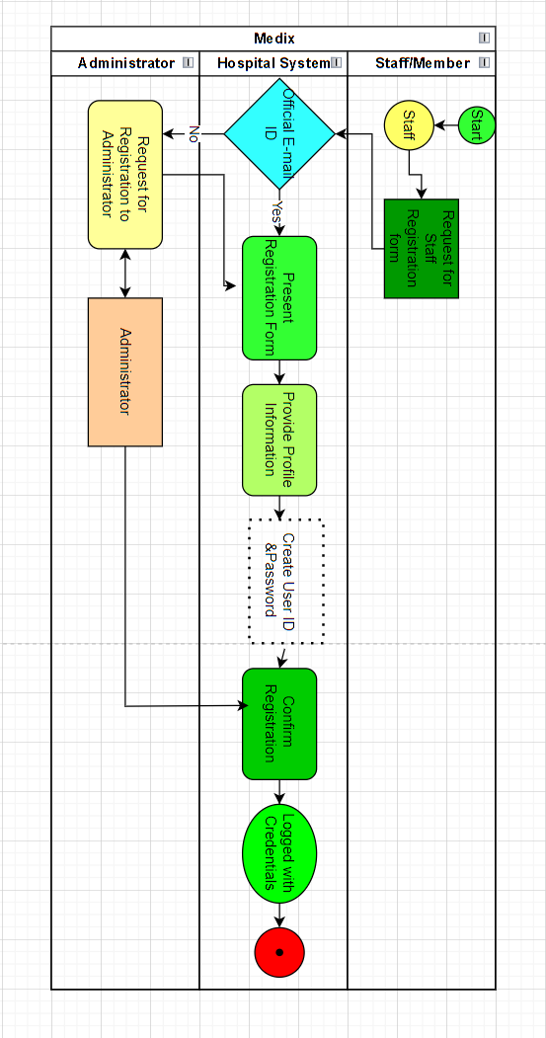

- The left swim lane represents the Hospital System, which is responsible for displaying the registration form, handling the submission, and providing confirmation to the staff.

- The right swim lane represents the Staff as an actor, who interacts with the system by requesting the registration form, filling it out, and submitting it for being registered into the system. Staff members need to register because the system will give the necessary access to the system and inside the hospital to the departments concerned without any pre-authorization.

- Each step in the process is indicated with a number and describes the action taken by either the Hospital System or the Staff actor. The system will provide also the number of steps that have been completed and can move directly backward in any step anytime within the registration process but within the allocated time given by the system.

- The arrows indicate the direction of information flow between the system and the actor.

- This swim lane activity diagram illustrates the sequential steps involved in the "Staff Registration" use case and the interactions between the system and the staff actor.

Deliverable #3 (1 mark) YUSUF
Using “Microsoft Visio” draw a use case diagram illustrating all the use cases identified in deliverable 1 above grouped by sub-system. Add the output to section #4 of your SRS document.
Click on the following link for details on how to draw use case diagrams using Microsoft Visio: Visio use case diagram
Below is use case diagram example:
Image source: Object-Oriented Technology From Diagram to Code with Visual Paradigm for UML. Curtis H.K. Tsang, Clarence S.W. Lau and Y.K. Leung.
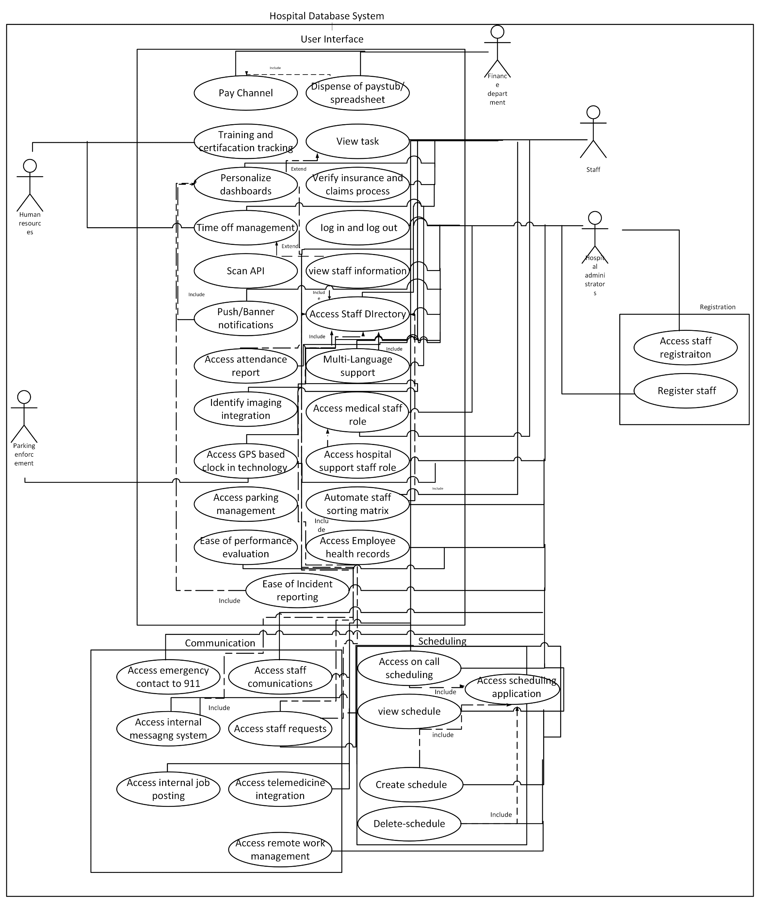
Deliverable #4 (2 mark) FATIMAH
Based on the use case descriptions, use the “Noun” technique to identify a list of analysis classes related to the domain problem/opportunity of your project. Brainstorm with your team to identify attributes related to each class and the class relationships, for example, binary association, inheritance…etc. and describe these relationships, for example, if a customer places an order, an order belongs to one customer. Draw, using “Microsoft Visio” a first-cut domain class diagram. Add the domain class diagram to Appendix E of your SRS document under class diagrams
Refer to Appendix 1 in your textbook for examples on Class diagrams, and the below links on how to Microsoft Visio
Visio class diagrams
Visio detailed class diagrams
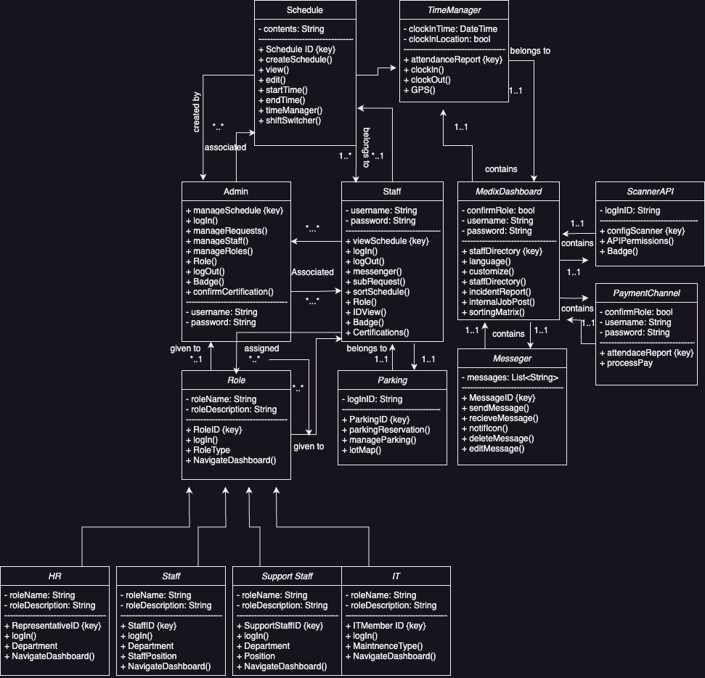
Inheritance: Role is the parent/super class to HR, Staff, Support Staff, and IT. They are all variants of Role.
1. Admin
- Manages: Staff (1..*)
- Manages: Schedule (1..*)
- Manages: Role (1..*)
- Uses: ScannerAPI (1..1)
2. Staff
- Has: Role (1..1)
- Has: Schedule (1..*)
- Uses: Messenger (1..1)
- Uses: TimeManager (1..1)
3. Schedule
- Managed by: Admin (1..1)
- Belongs to: Staff (1..1)
4. Messenger
- Used by: Staff (1..1)
5. Role
- Managed by: Admin (1..1)
- Assigned to: Staff (1..1)
6. ScannerAPI
- Used by: Admin (1..1)
7. TimeManager
- Used by: Staff (1..1)
8. PaymentChannel
- Processes pay for: Staff (1..*)
9. MedixDashboard
- Used by: Admin (1..1)
- Used by: Staff (1..1)
10. Parking
- Used by: Staff (1..1)

Deliverable #5 (2 mark) due week 8 for professor review and feedback
Fatimah
Brainstorm with your team to develop a set of Class responsibilities and collaboration “CRC cards” for all entity type classes. Add the CRC index cards to Appendix E of your SRS document under class diagrams.
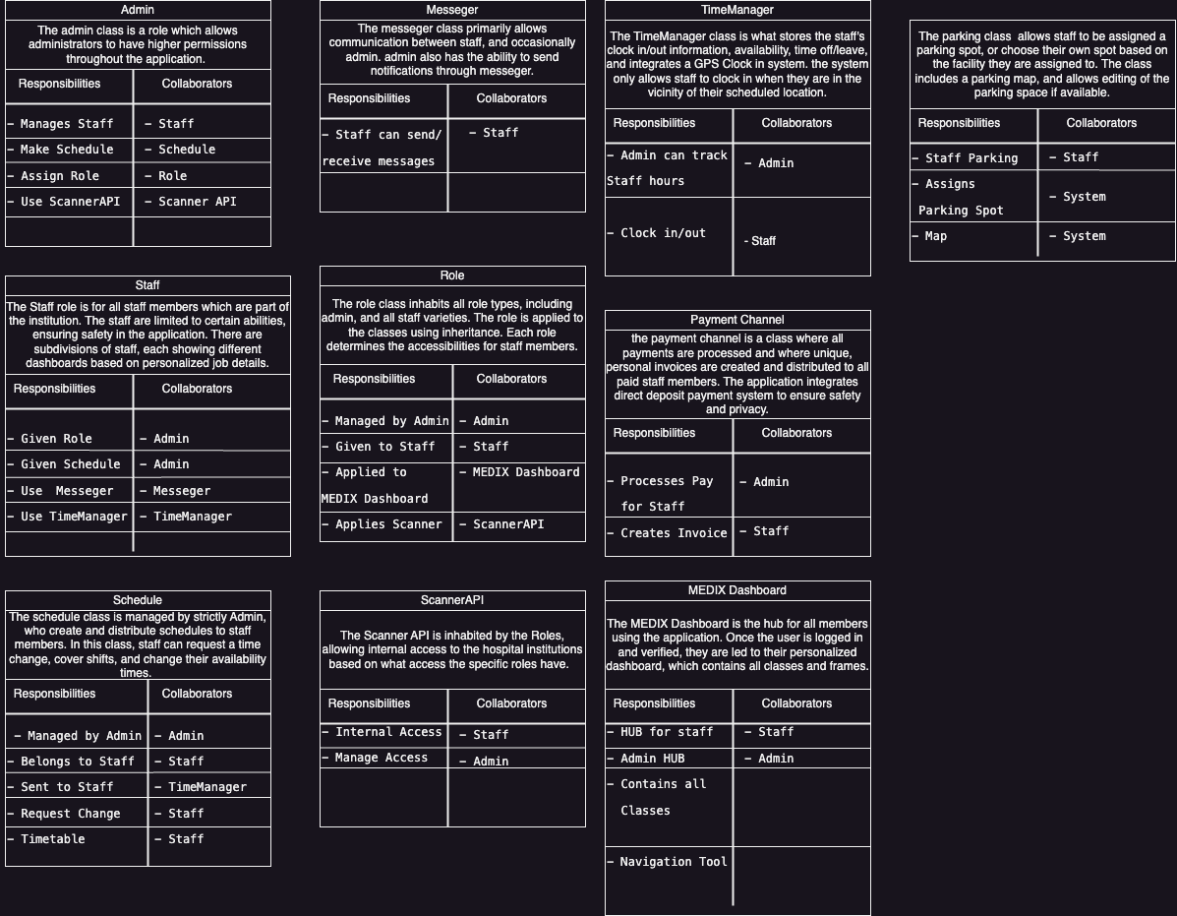

Deliverable #6 (2 mark) Fatimah
Based on the responsibilities and collaborations identified in your CRC index cards update your first cut domain class diagram with the following:
a. Class attribute descriptions and visibilities
b. Signature methods with the respective parameters and visibilities
Add the class diagram to Appendix E of your SRS document under class diagrams.



